**Lab manual : Database Systems**

**Roll Number : info-Tech-15024**

**Submitted to : Ma’am Samia *Sweet***

**Task 1: ERD Diagrams**

**Lab Exercise**

**Question 1:** The Company sells a number of different furniture products. These products are grouped into several product lines. The identifier for a product is Product ID, while the identifier for the product line is Product Line ID. Referring to the customer invoice, we identify the following additional attributes for product: Product Description, Product Finish and Unit Price. Another attribute for Product line is Product Line Name. A product line may group any number of products but must group at least one product. Each product must belong to exactly one product line. Customers submit orders for products. The identifier for an order is Order ID, and another attribute is Order Date. A customer may submit any number of orders or may not submit any orders. Each order is submitted by exactly one customer. The identifier for a customer is Customer ID, and other attributes include Customer Name and Customer Address. A given customer order must request at least one product. Any product sold by Pine Valley Furniture may not be requested on any order, or may be requested one or more orders. An attribute associated with each order and product is Quantity, which is the number of unit is requested.

**Question 2:** Assume you have been contracted by a university to develop a database system to keep track of student and accommodation records. The university courses are offered by facilities. Depending on the student’s IQ, there is no limitations to how many courses a student can enroll in. The faculty are not responsible for student accommodation. The university owns a no of Hostels and each student is give a room key after enrollment. Each room has furniture attached to it.  
Draw the ERD diagram with the additional enhanced concept.

**Table1:** Name: airplane

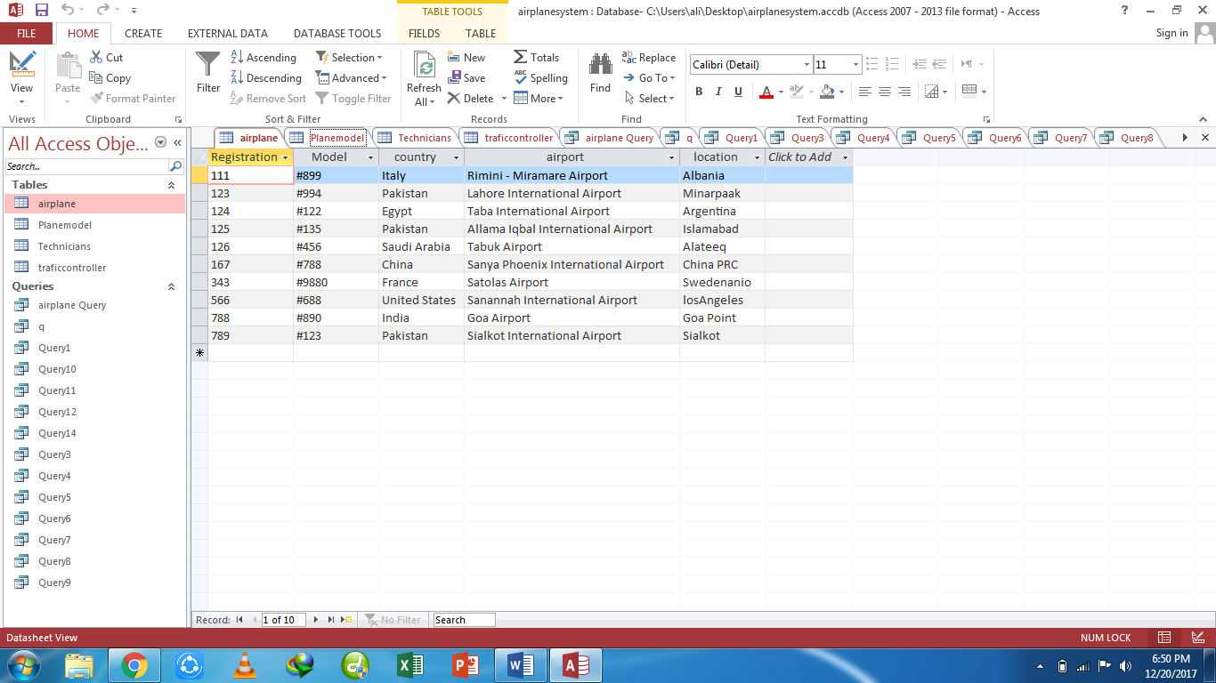

**Table2:** Name: Planemodel

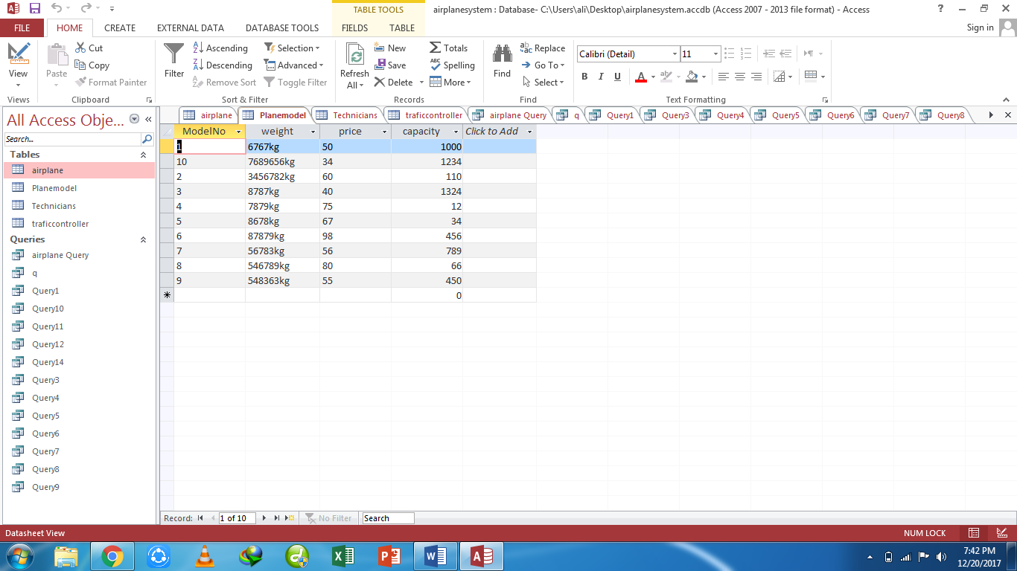

**Table3:** Name: Technicians

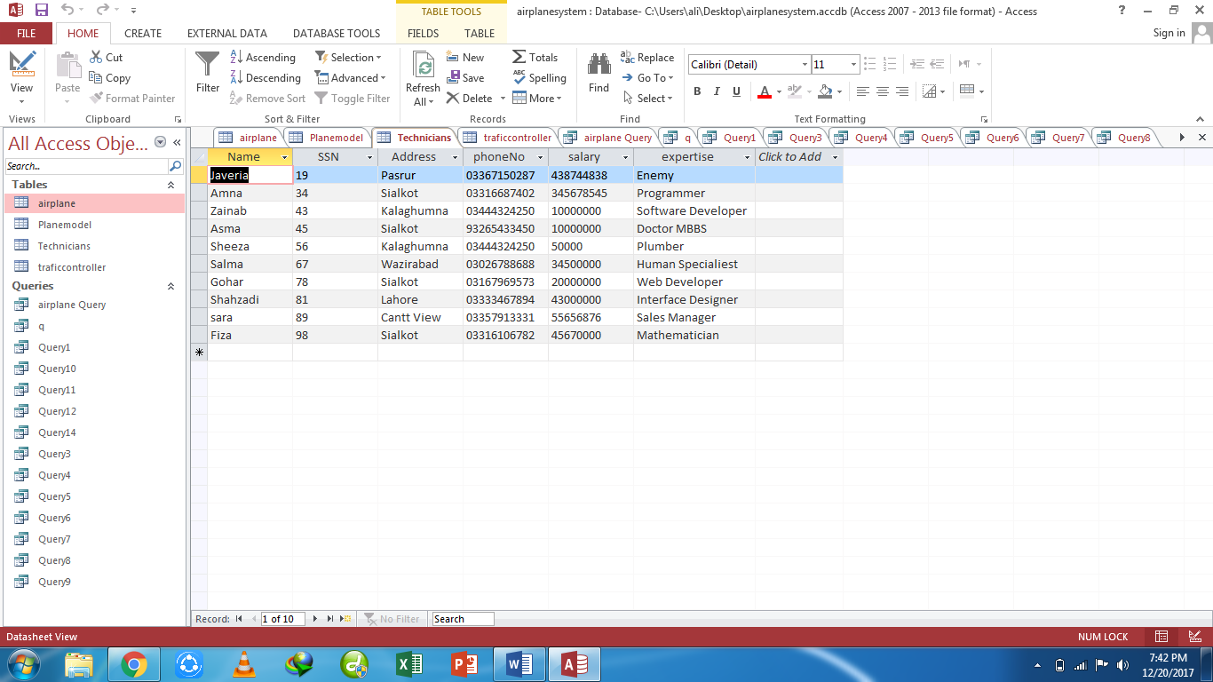

**Table4:** Name: Traffic controller

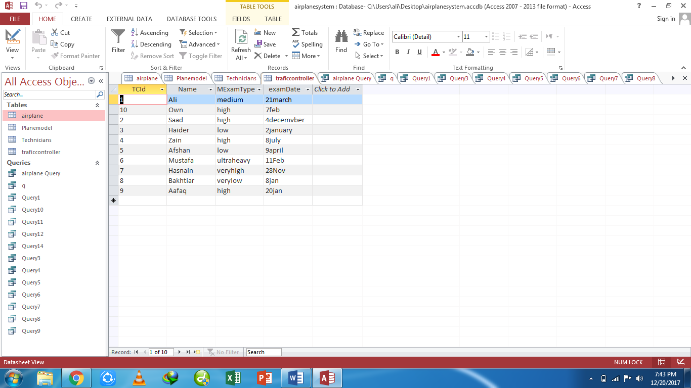

**(Queries)**

**Query1**) Display details of all airplanes.

**Design view:**

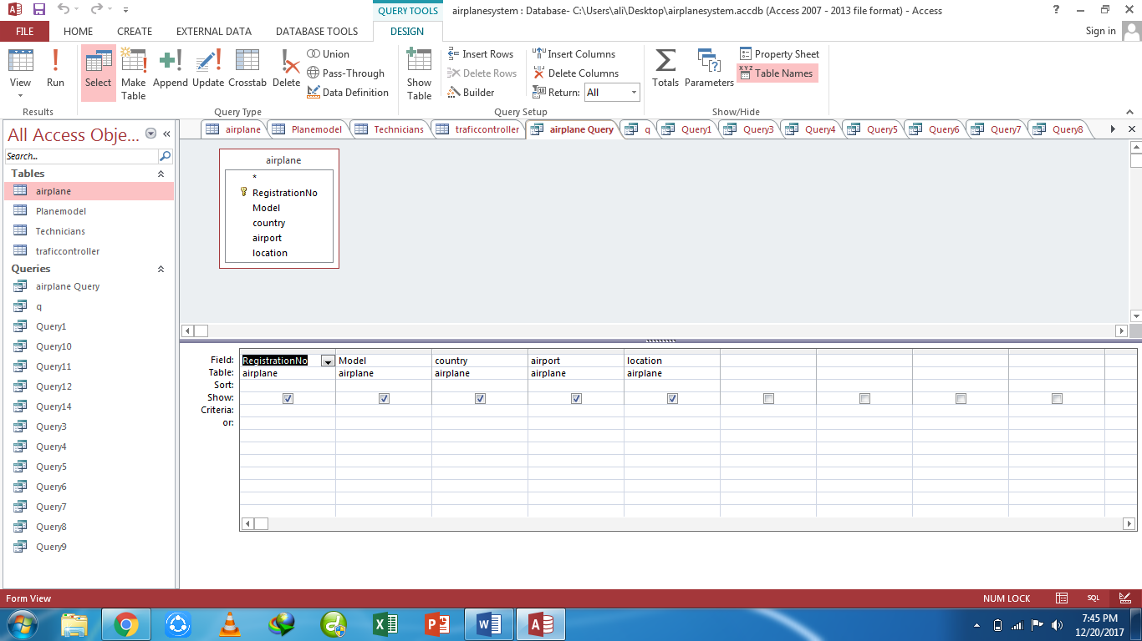

**Datasheet view:**

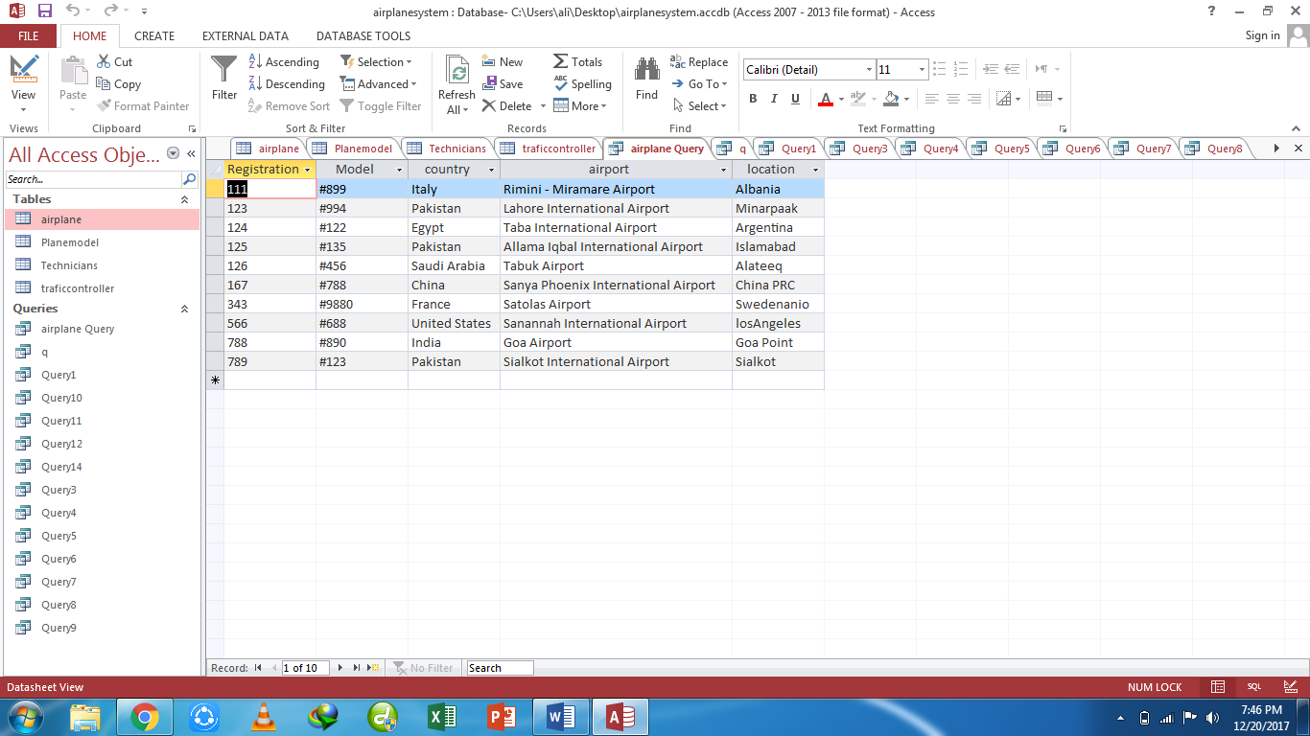

**Query2)** List detail of total exams conducted and exam type

**Design view:**

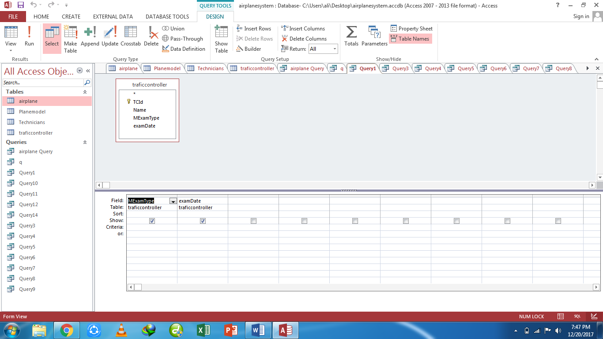

**Datasheet view:**

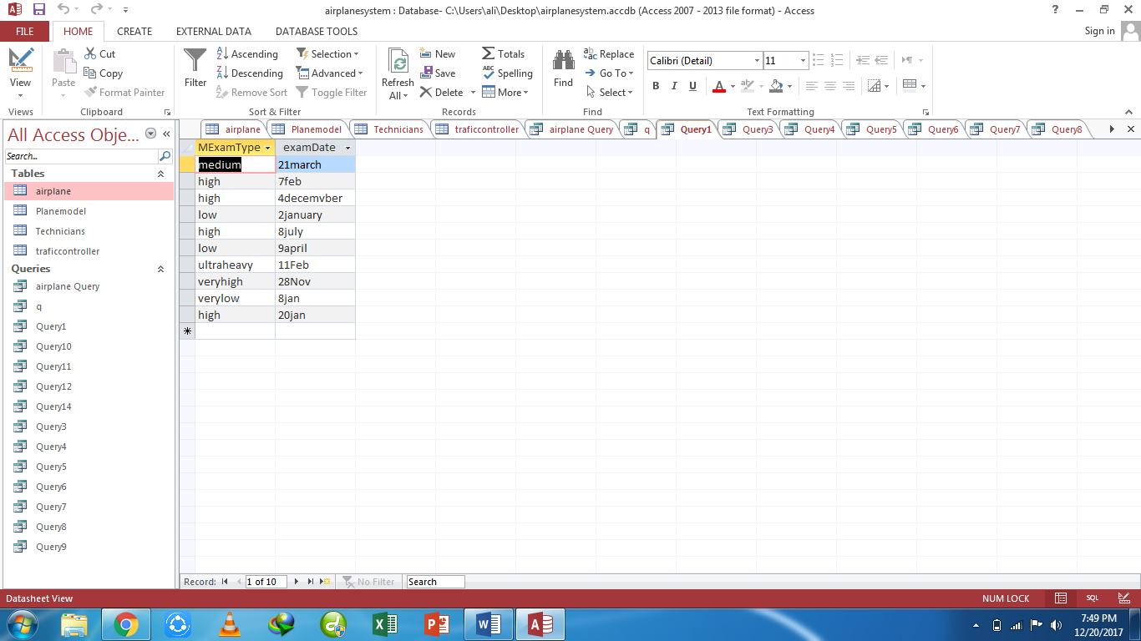

**Query3)**: list model and price of all planes

**Design view:**

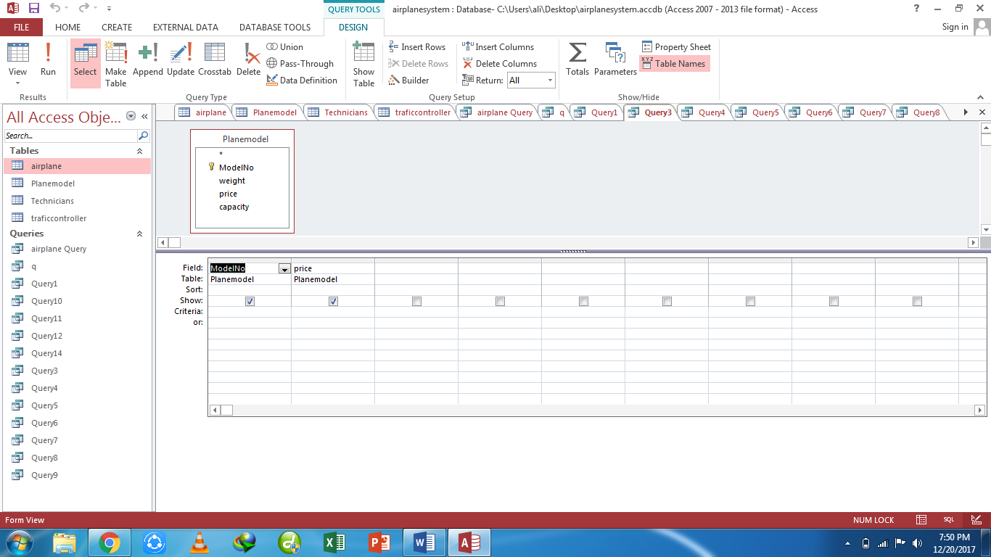

**Datasheet view:**

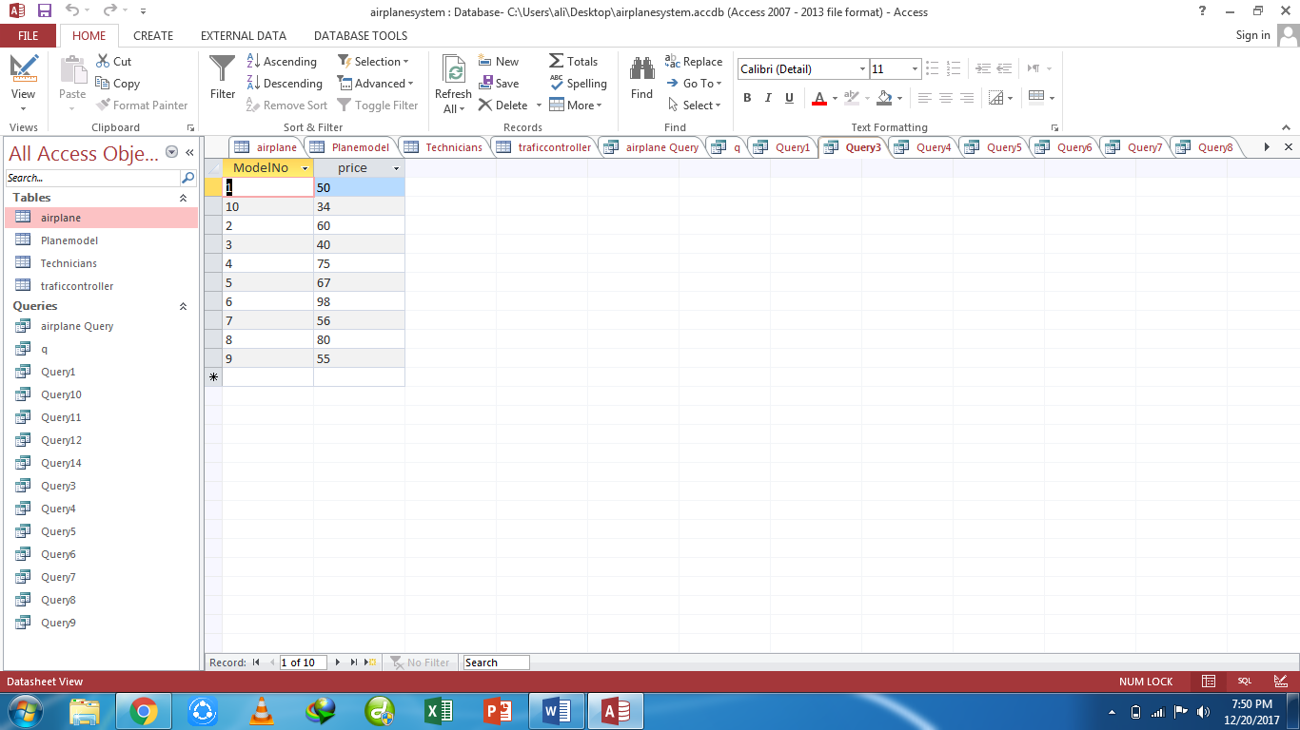

**Query4):** list price and capacity of all planes

**Design view:**

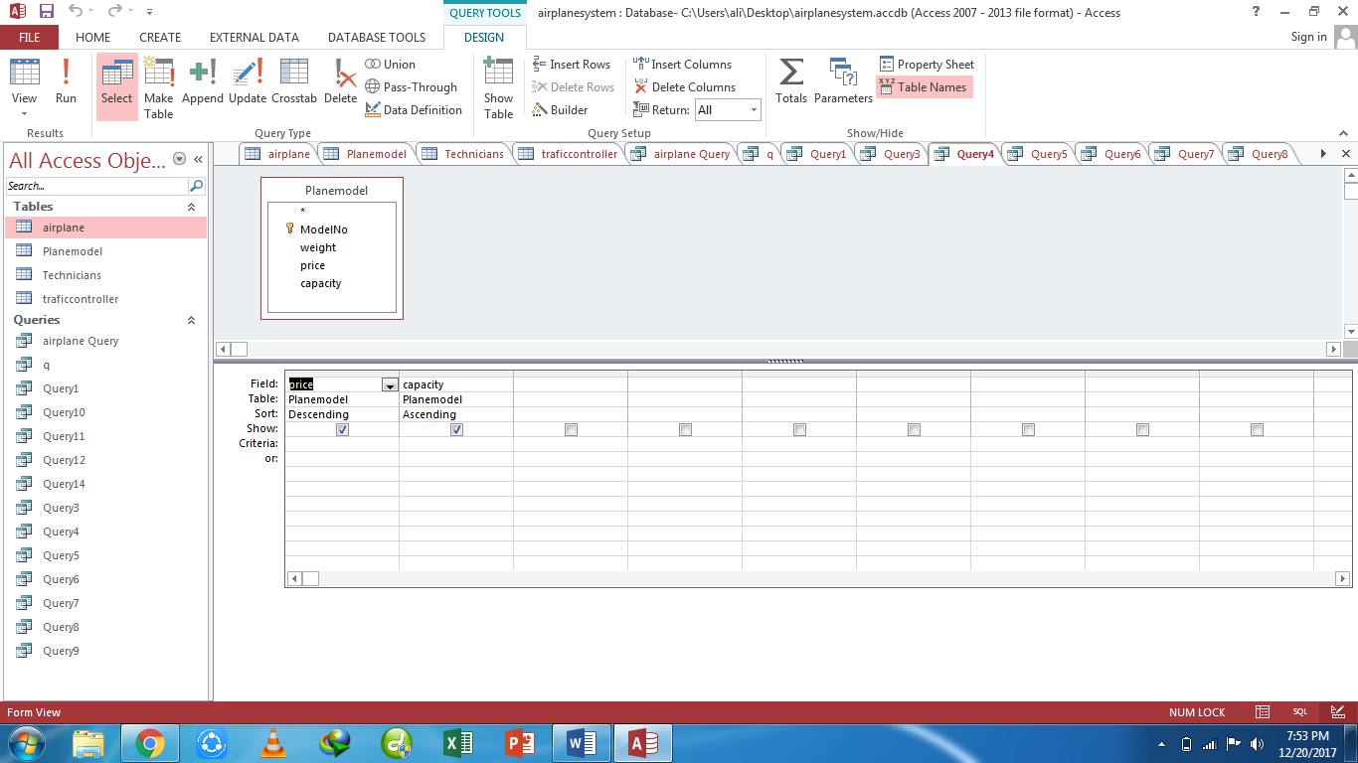

**Datasheet view:**

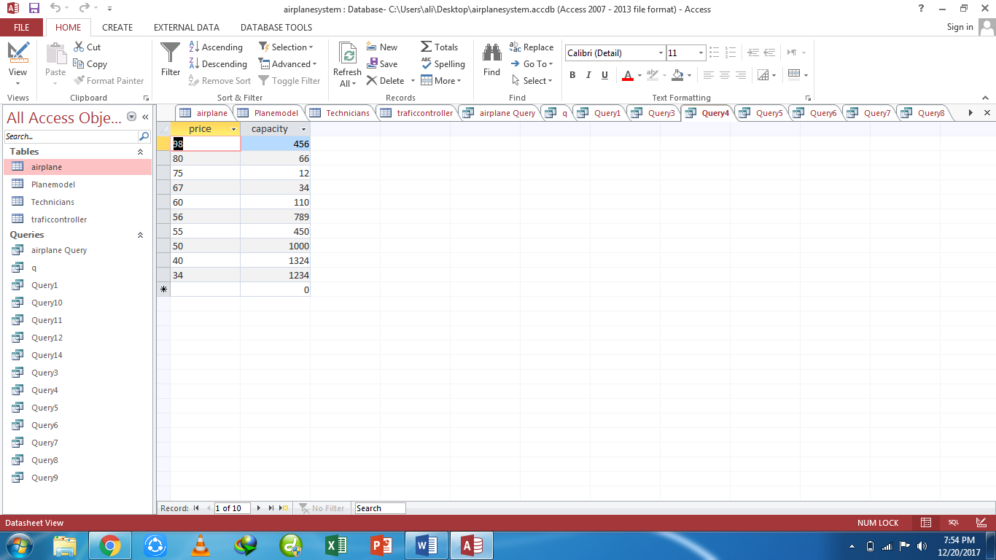

**Query5):** list those planes whose prices are between 20 and 80 millions

**Design view:**

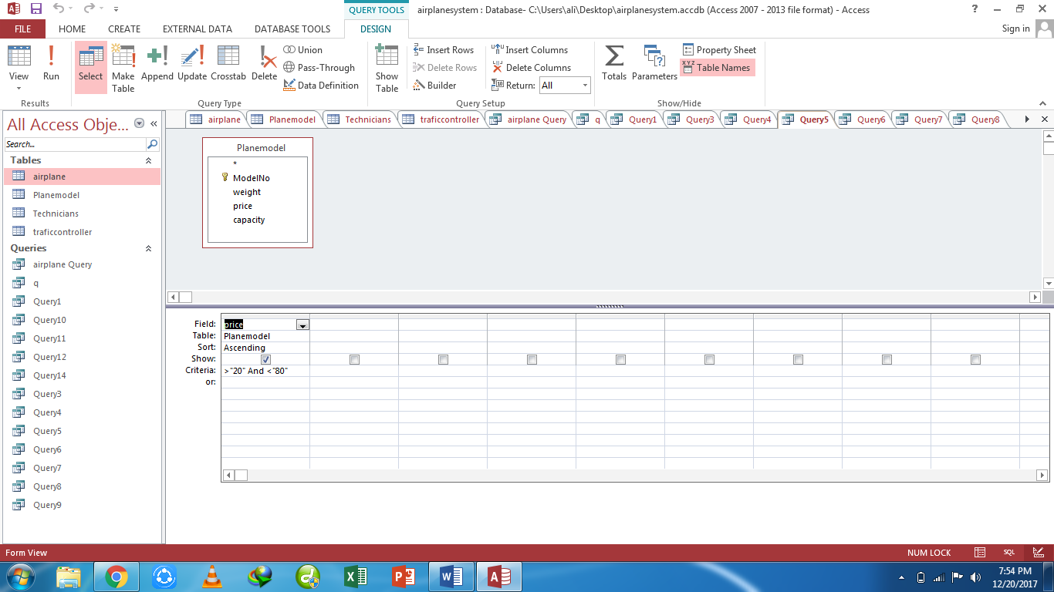

**Datasheet view:**

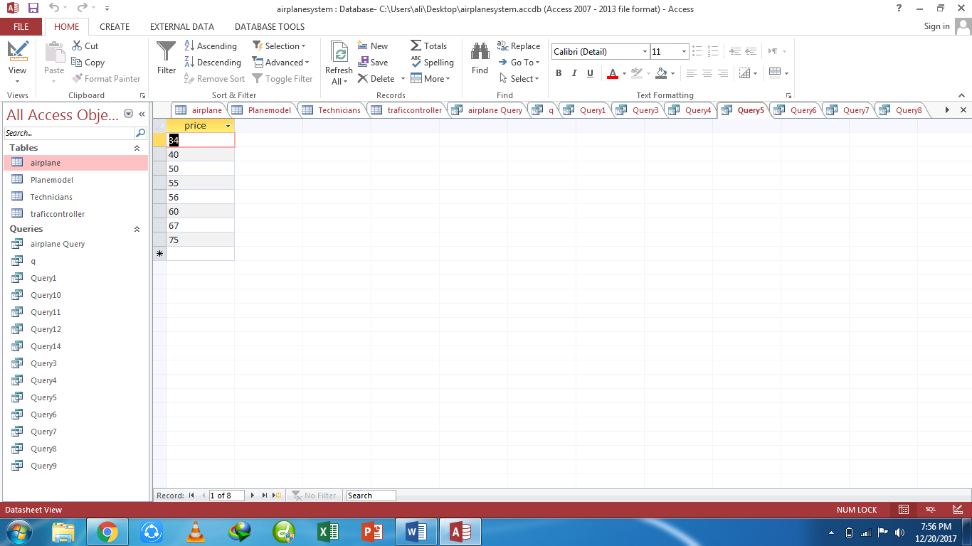

**Query6)** list total plane models

**Design view:**

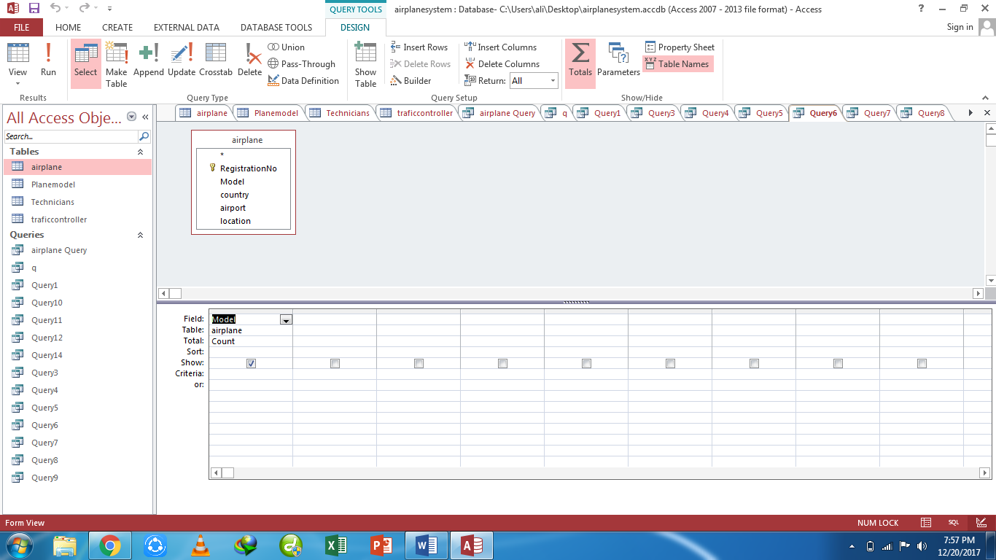

**Datasheet view:**

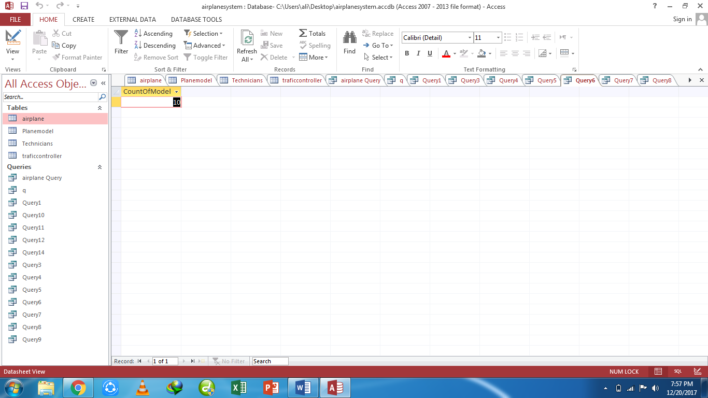

**Query7:** List average price of planes

**Design view:**

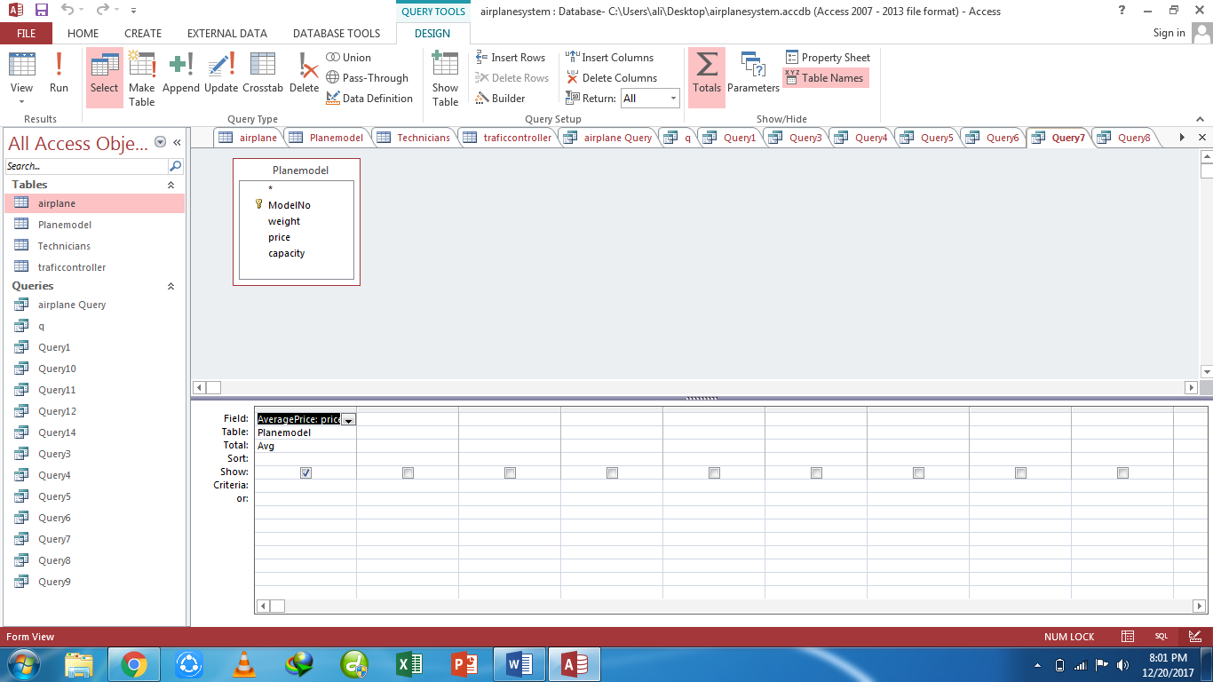

**Datasheet view:**

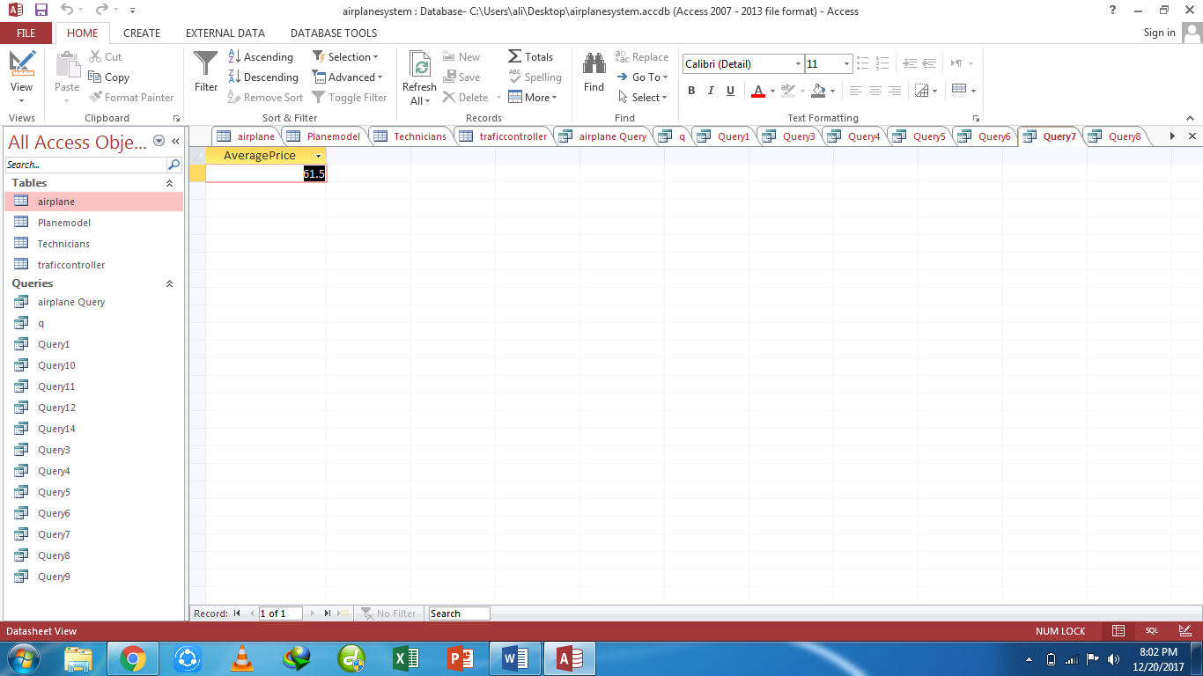

**Query8**) list number of total exams conducted

**Design view:**

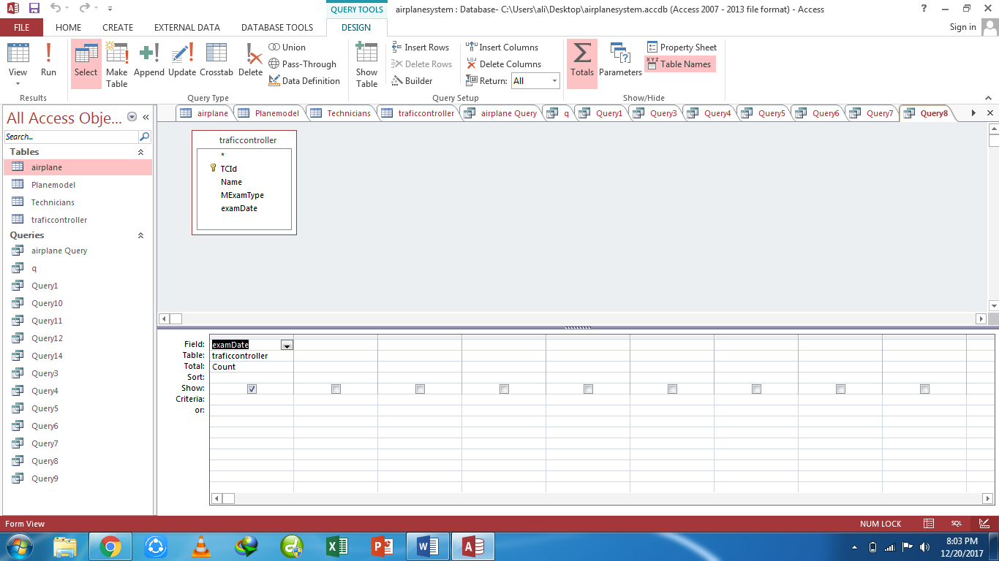

**Datasheet view:**

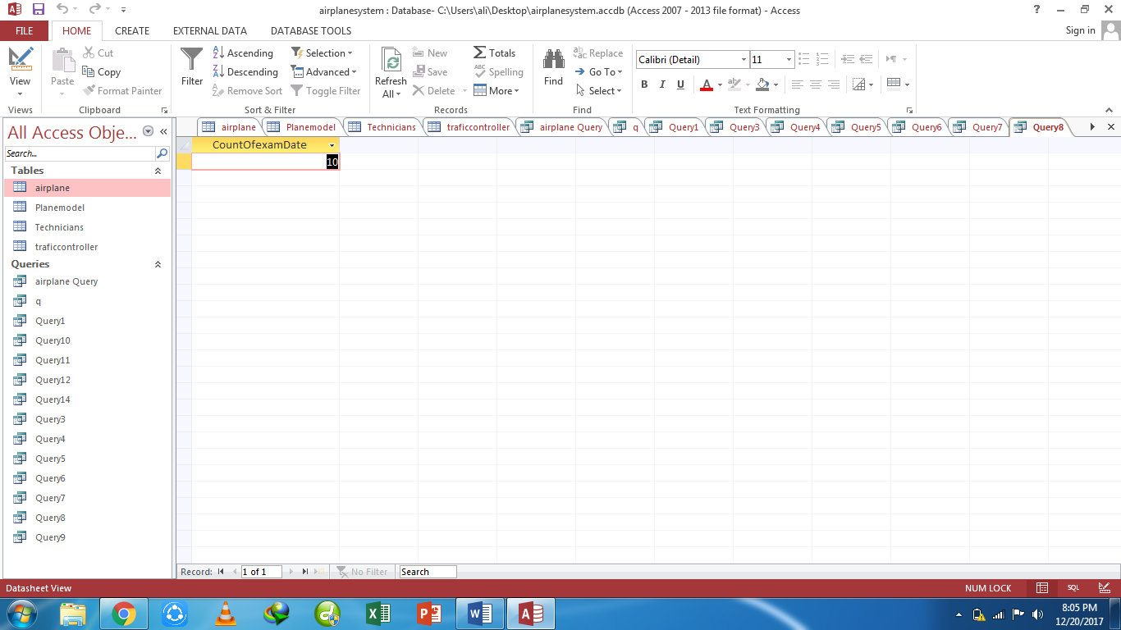

**Query9)** list the name of technicians from Sialkot

**Design view:**

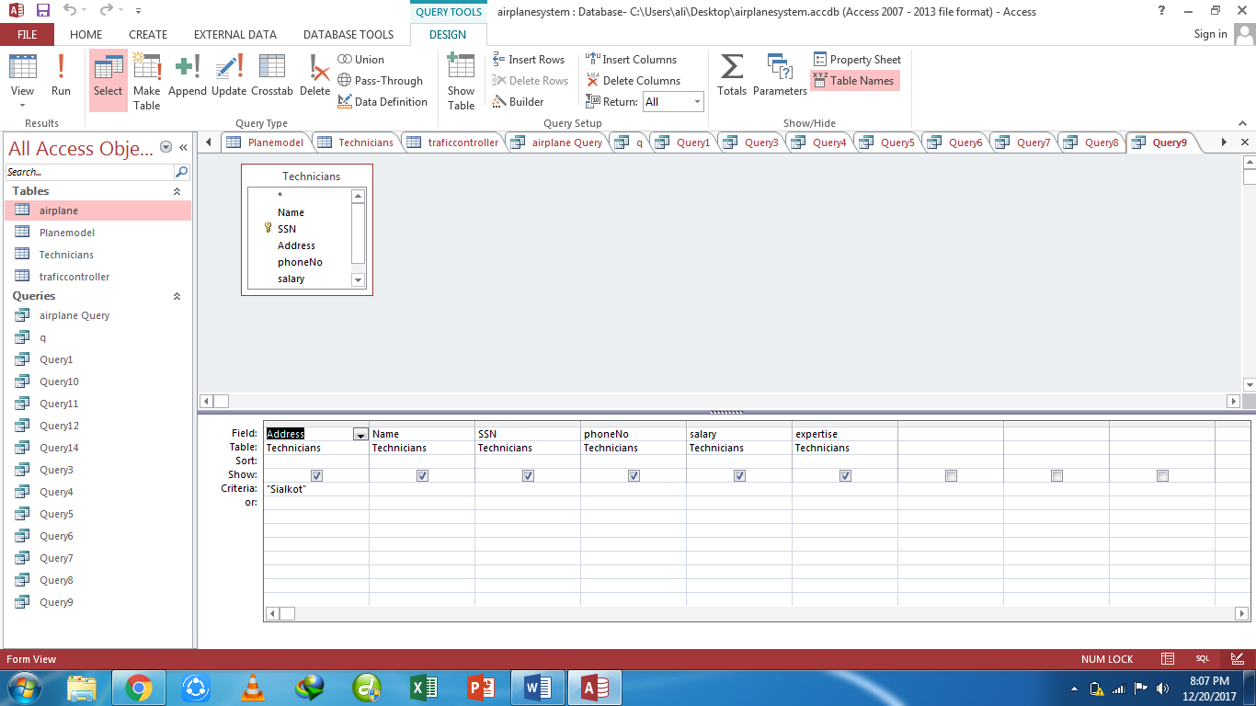

**Datasheet view:**

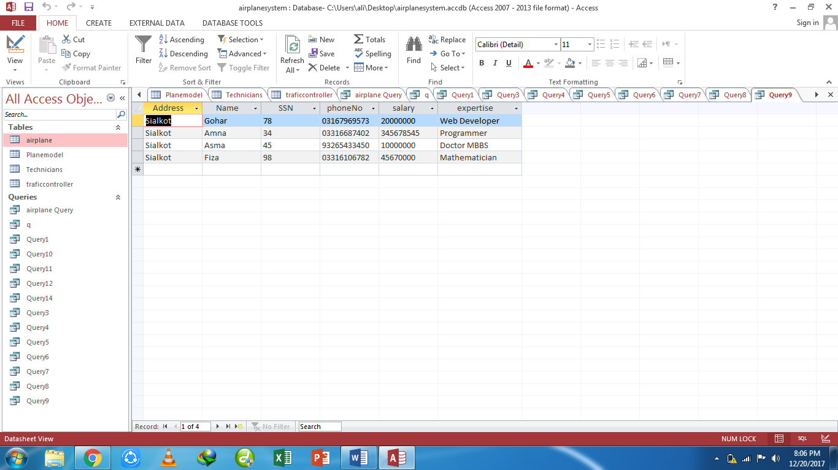

**Query10)** list name of those technicians whose names contains “sa”

**Design view:**

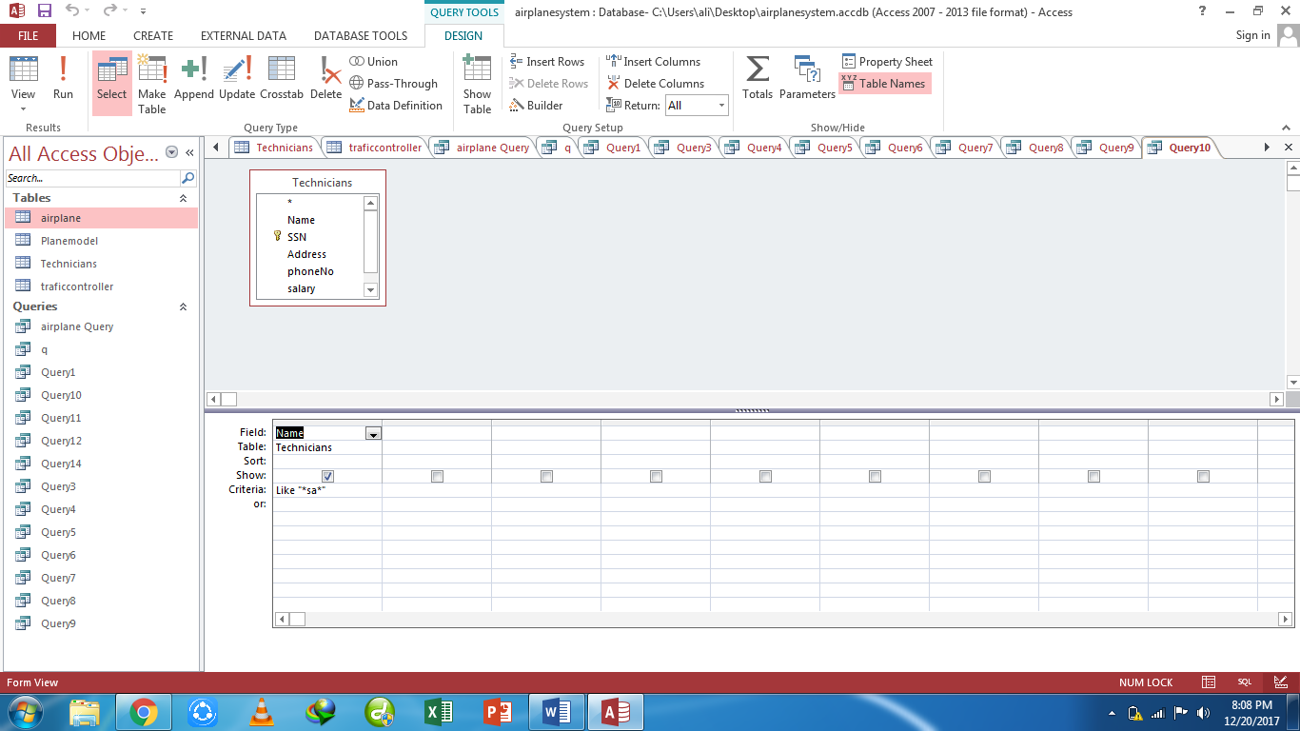

**Datasheet view:**

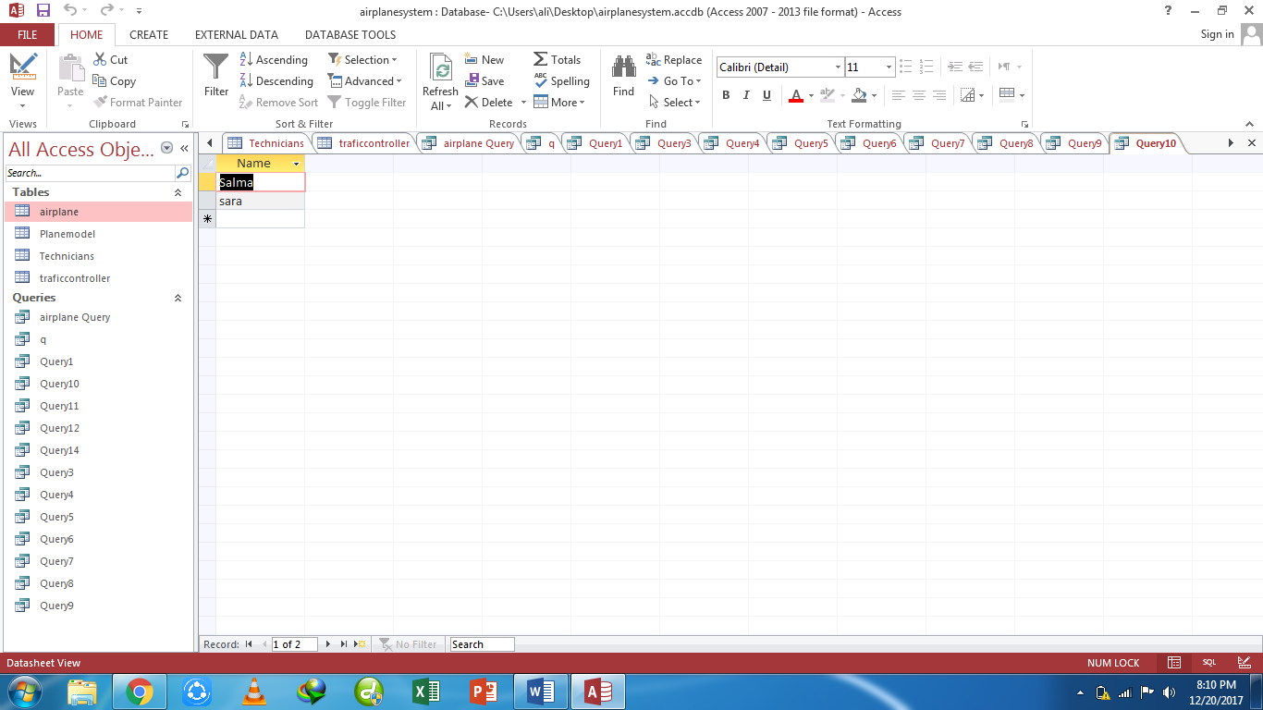

**Query11)** list the planes which can carry passengers more than 110

**Design view:**

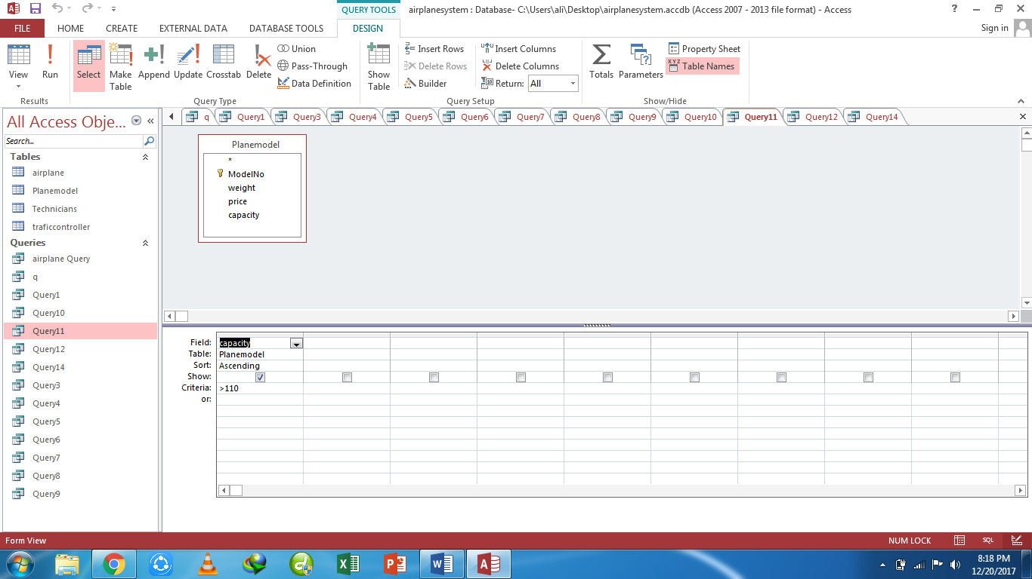

**Datasheet view:**

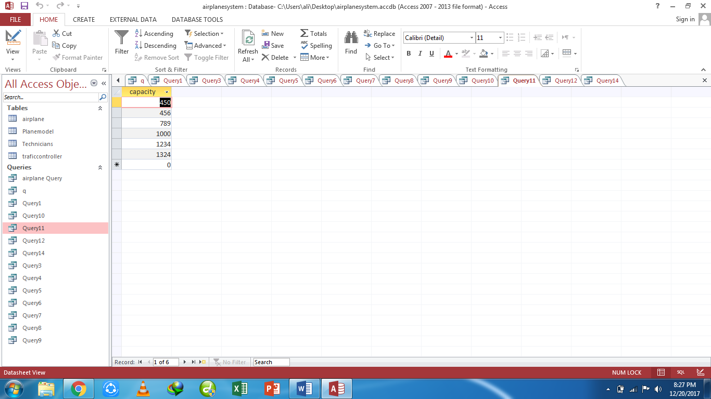

**Query12)** list the minimum capacity and maximum capacity of planes

**Design view:**

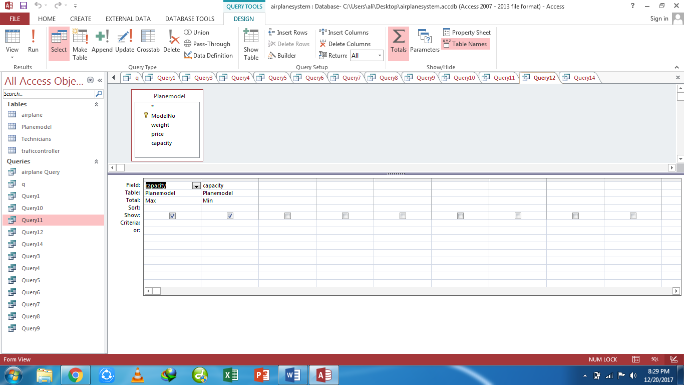

**Datasheet view:**

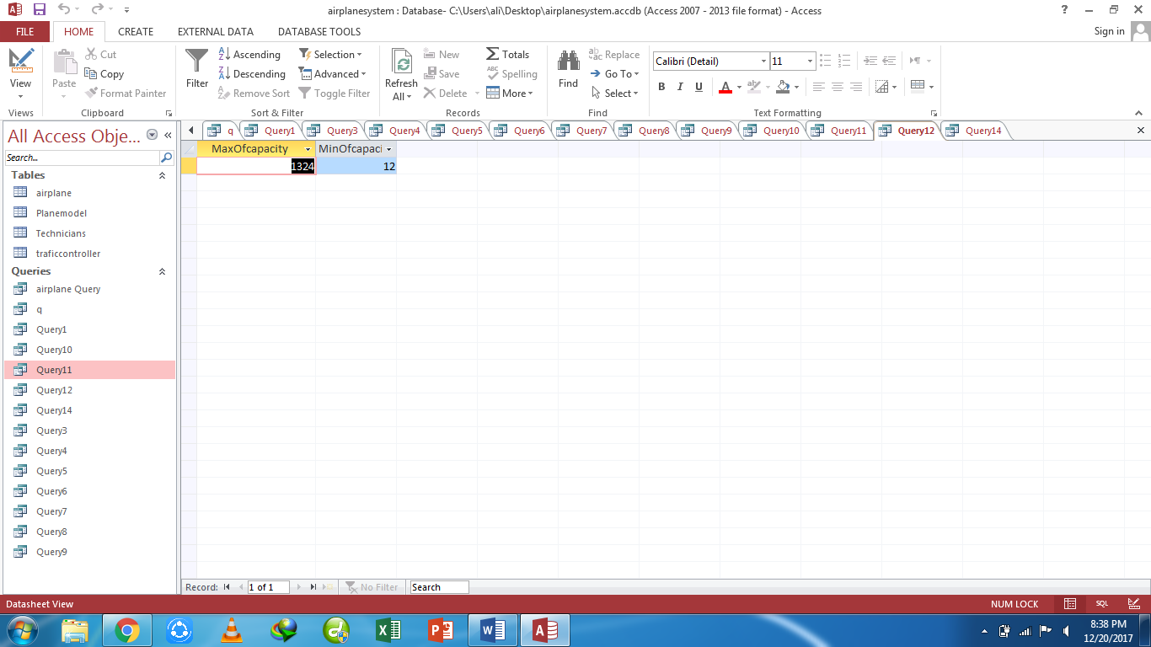

**Query13)** list the planes which location is Sialkot and Islamabad

**Design view:**

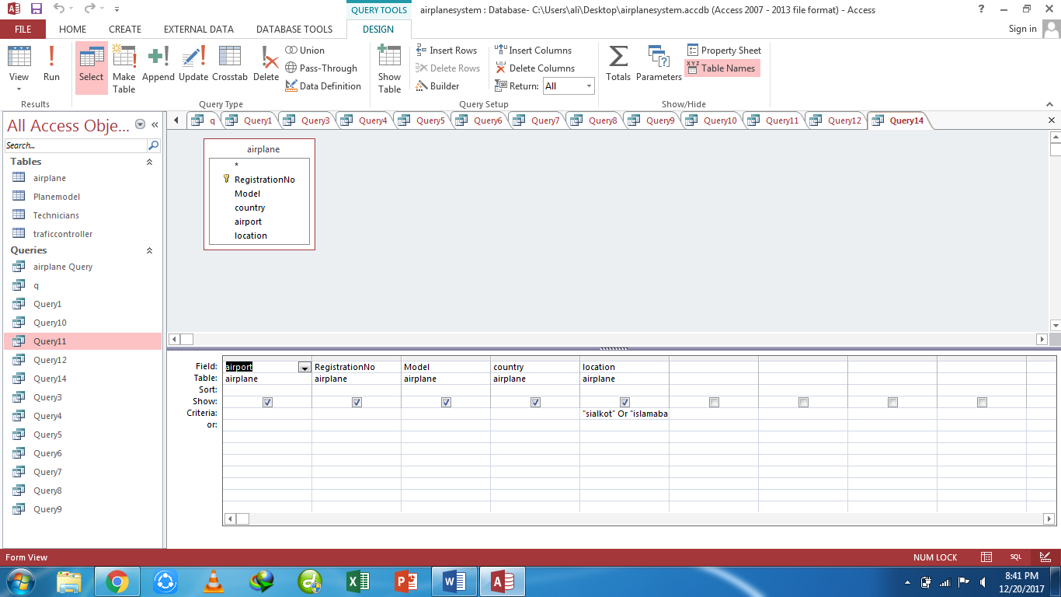

**Datasheet view:**

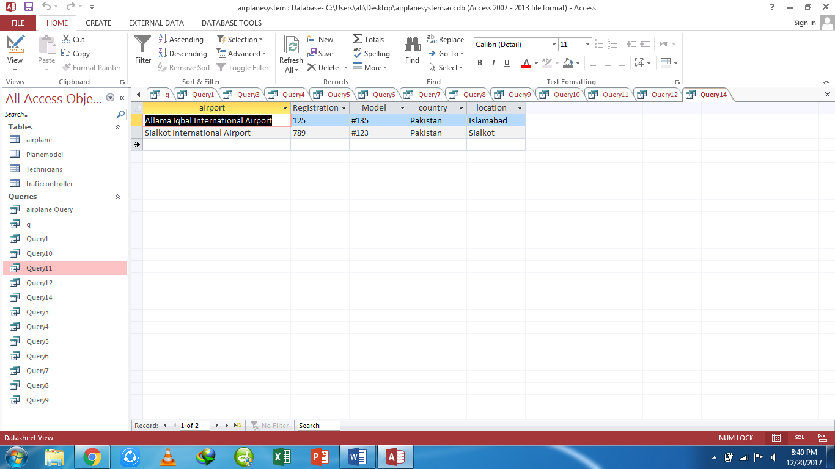

**Query14)** List the data of those technicians whose exam type contains

**Design view:**

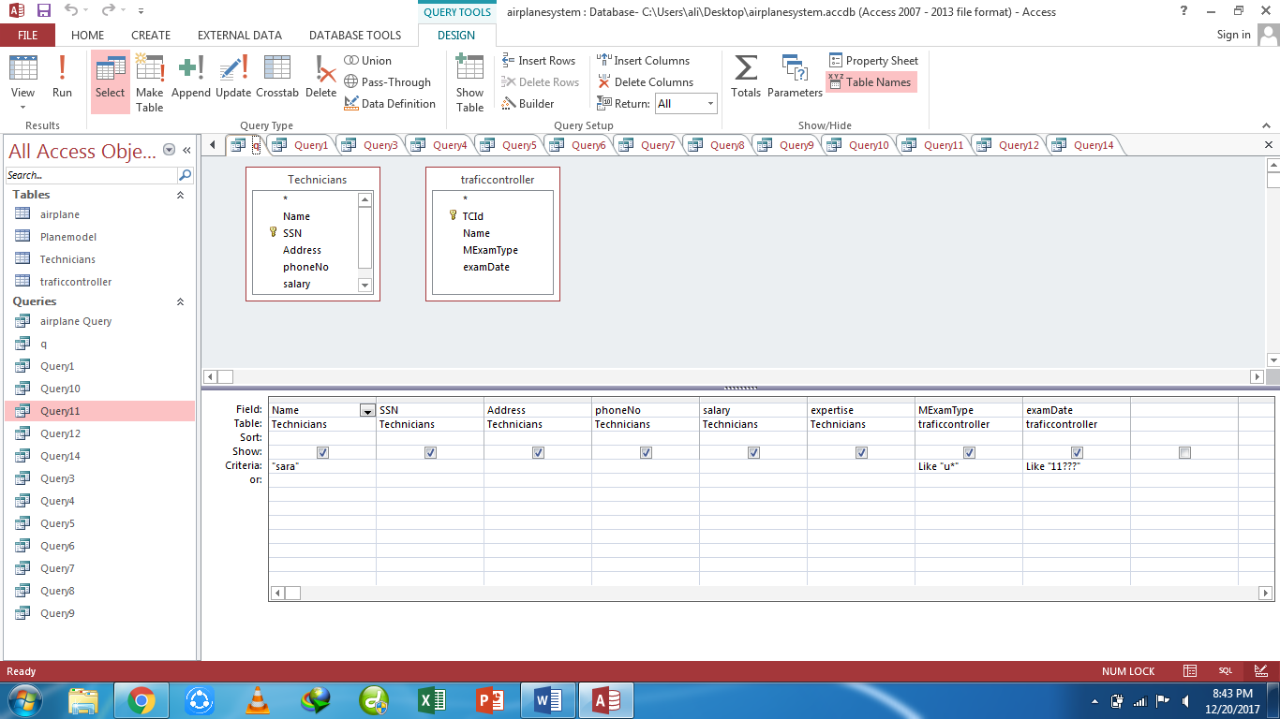

**Datasheet view:**

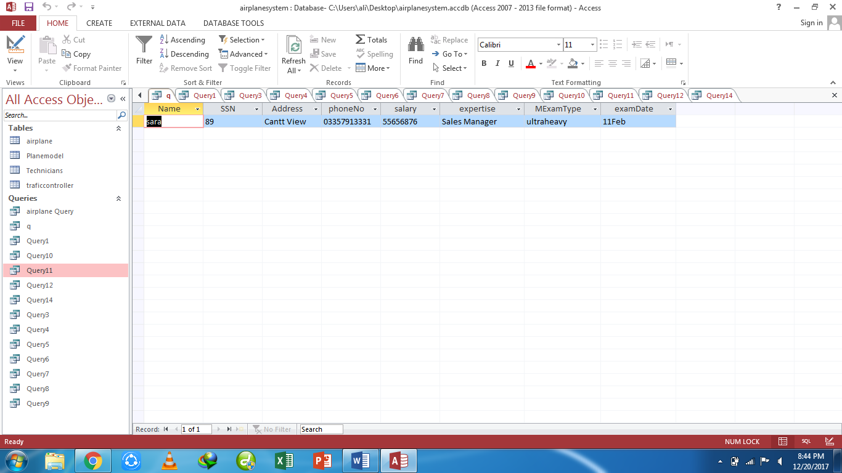

**Task3:** Create tables for students’ data of IT 5th whole record of previous semesters.

**Design view:**

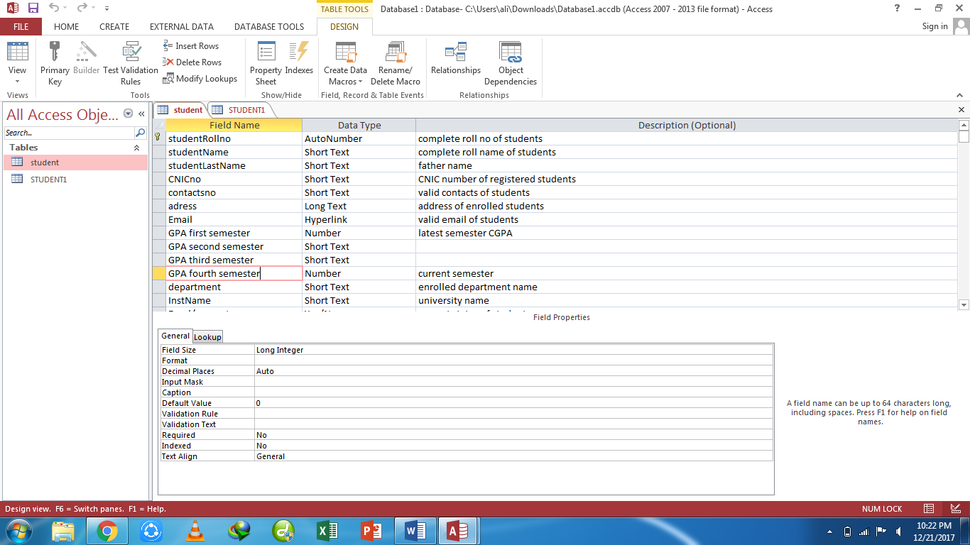

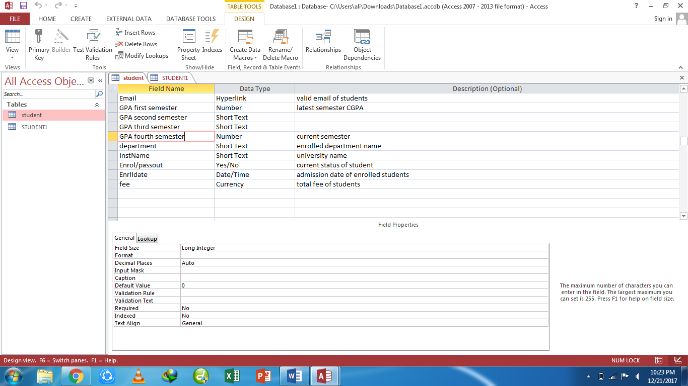

**Datasheet view:**

